embedUR Systems
Campus Training Program – 2026
LINUX TRAINING – ASSESSMENT 1
Name : Muhesh M
College :Thiagarajar College of Engineering, Madurai.

- Create a file and add executable permission to all users (user, group and others)

Commands:
- touch file1
- chmod a+x file1
- ls -lrt

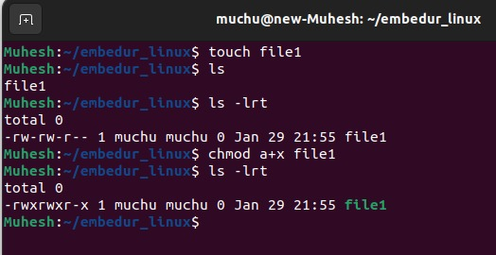

- Create a file and remove write permission for group user alone

Commands:
- touch file2
- chmod g-w file2
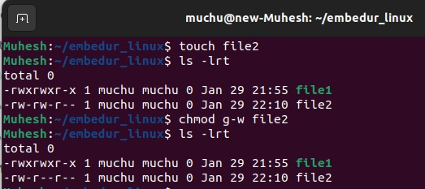
- ls -lrt

- Create a file and add a softlink to the file in different directory (Eg : Create a file in dir1/dir2/file and create a softlink for file inside dir1)
Commands:
- mkdir -p dir1/dir2
- touch dir1/dir2/file
- ln -s dir1/dir2/file dir1/file_softlink
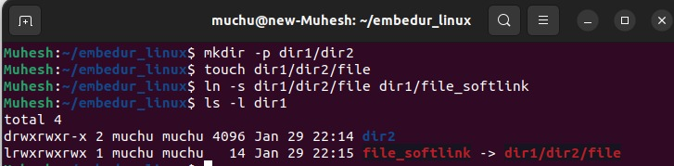
- ls -l dir1

- Use ps command with options to display all active
process running on the system
Commands:
    - ps aux
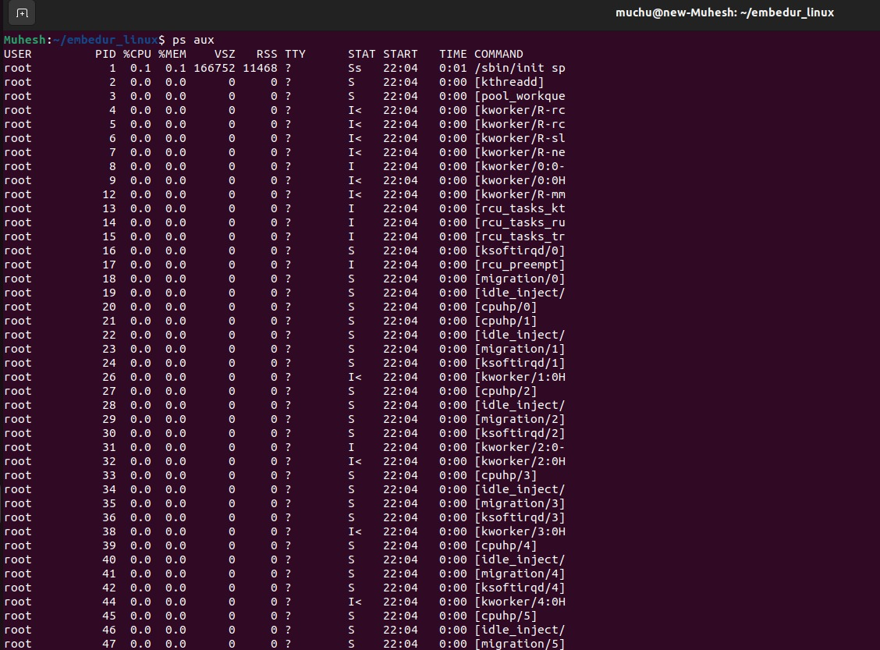

- Create 3 files in a dir1 and re-direct the output of list command with sorted by timestamp of the files to a file

Commands:

- mkdir dir1
- touch dir1/file1
- sleep 5
- touch dir1/file2
- touch dir1/file3
- cat op.txt
- ls -lt dir1 > op.txt
